
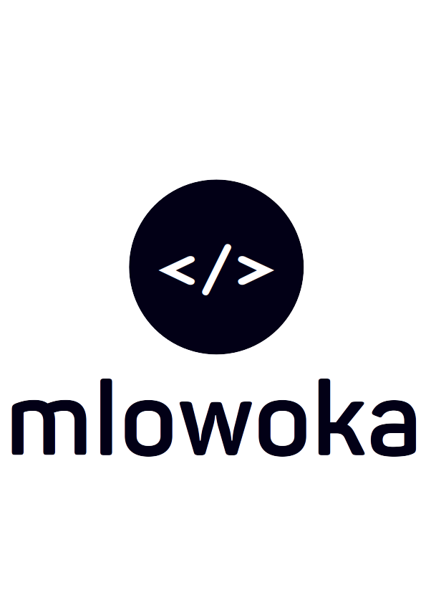
MCOMAT SYSTEM

MEETING REPORT NO. 1001 ON MEMO NO. 1001

The Managing Director  Mzimba College of Management & Technology  P.O Box 40  Mzimba  Dear Sir | John Kabatika Chirwa (King Mlowoka)  kingmlowoka16@outlook.com  (+265) 881 88 94 87  February 6, 2024

REPORT ON SCRUM MEETING
I write this memo to request a meeting tomorrow, 31st January 2024, at 1630 concerning the MCOMAT system being developed. The MCOMAT System is an information system currently only deploying student tasks in the academics section currently...

CC: Registrar
Dean of Academics
Director

